Carleton University

**Assignment 2**

SYSC5104 Meth Discrete Event Modeling

Fall 2021

Dr. Cristina Ruiz Martin

Mahya Shahmohammadimehrjardi

Student ID: 101213253

# ***Introduction***

The goal of this project was to study the effect of radiation damage to the tumor in Cell DEVS as it has been studies before in Cell automata in [1]. In [1], they first simulate the tumor in Cell automata using the method specification in [2] and when the number of tumor cells have been reached 40,000, the radiation therapy has been started. That is why I have modeled a tumor in Cell DEVS from [2] in order to be able to apply the radiation effect to it in future.

In [2], two types of cancer cells are defined. Cancer Stem Cells (CSCs) and progenitor cells. CSCs are the type of cells which are considered immortal in the absence of treatments such as ionized radiation and as the result known as the reason of tumor formation since they can proliferate limitless if not treated, while progenitor cells get mature and eventually die after a certain number of cell division.

In this project, I have simulated a situation where there are a few cancer cells from both progenitors with different proliferation capacities (10 and 20) and CSCs existed.

# ***Cell DEVS Description***

Two types of progenitor cells and CSCs are described in the simulation. Four states have been dedicated to this model; state 0 defines no existence of cancer cells, state1 describes the situation where a progenitor cell with $ρ_{max}$ =10 is existed, state 2 describes the situation where a progenitor cell with $ρ_{max}$ =20 is existed and state 3 describe the existence of a CSC. . For the ease in coding, instead of decreasing $ρ$ by 1 after each cell division (such as 20 to 19 or 10 to 9), it is assumed that the time delay is such a way that after each time step the value of $ρ$ is decreased by 10 so each progenitor cell gets close to maturation and dying stage after each delay.

Another rule is that each cancer cell can migrate if they have enough space to migrate. The worst case scenario for cancer cell migrations has been considered because it is better to be pessimistic rather than optimistic when it comes to modeling catastrophic phenomena such as cancer. The cell with higher $ρ$ value has been prioritized to migrate if migration is possible.

In the .pal file, cell colors are defined as; red for state 3, orange for state 2, yellow for state 1 and white for state 0.

The code in CD++ is shown in Figure.1.

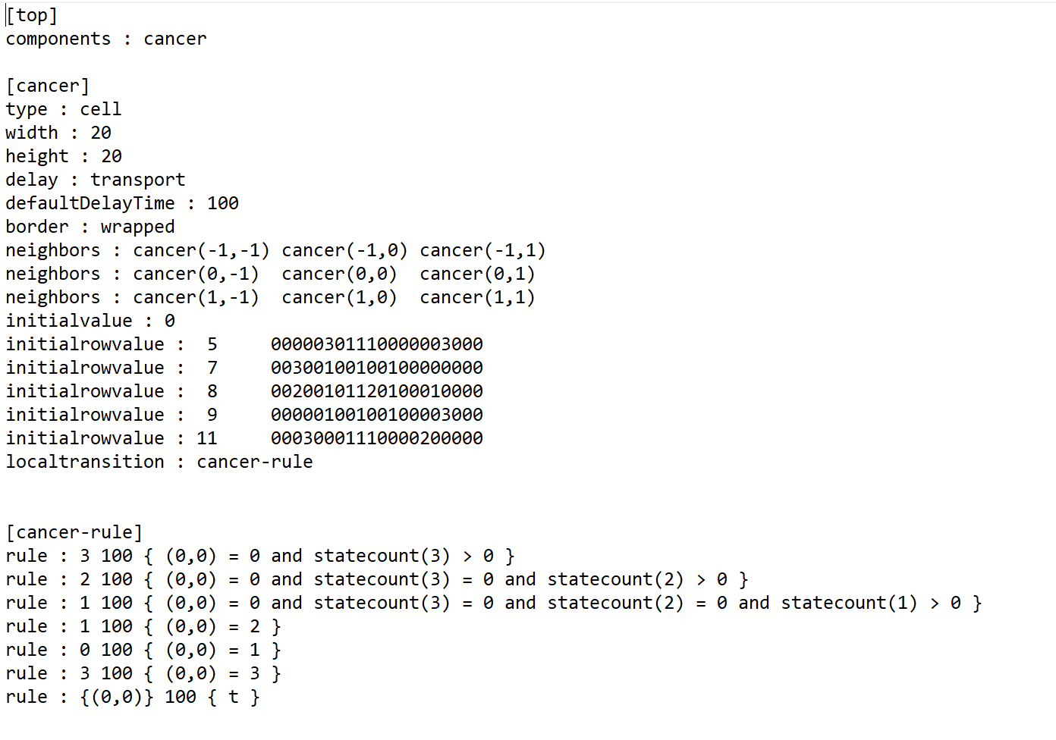

**Fig. Top model of the second case in CD++**

# ***Result***

It is shown that, because of existence of CSCs, eventually all the cells become CSCs witch forms a tumor that mitosis to the whole body. In [2], it is shown that in the absence of CSCs, even if the progenitor cells have a high proliferation capacity number, they are not able to form a tumor.

In future the radiation effect on these CSCs can be modeled as in [1].

The repositories are in the link below:

<https://github.com/mahyashah/cancer.git>

# ***References***

[1] E. Fourkal, I, Veltchev, et al, "Cellular automaton model of radiation damage to the tumor", Cancer Res., 10.13140/RG.2.2.30940.62084, (2020).

[2] H. Enderling, A. Anderson, M. Chaplain, et al, "Paradoxical dependencies of tumor dormancy and progression on basic cell kinetics", Cancer Res., 69, 8814-8821, (2009).